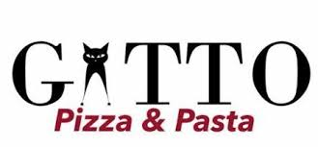
FAMILY HOLIDAY MENU*
*Serves parties of 4-6ppl. Must PREORDER trays in advance

Caesar Salad 6ppl tray 70.00
Romaine , croutons, parmesan, Caesar vinaigrette dressing made in house.

tuscan Kale Salad 6ppl tray 70.00
Organic Kale, lemon vinaigrette, sunflower seeds, dry cranberries, parmigiano.

Chicken Parm 6ppl tray 100.00
Tray of 6 chicken cutlets and in a rich sugo sauce, Side of penne pomodoro.

Eggplant parm 6ppl tray 100.00 (VEG, GF)
Tray of 6 shortribs, accompanied by a tray of mashed potatoes and roasted veggies, in a Demiglaze sauce.
Penne Alla Vodka 6ppl tray 80.00
Hearty penne pasta tossed with a creamy Rose sauce, and Parmigiano.

Alfredo Pasta 6ppl tray 80.00
Spaghetti pasta in a house made creamy Alfredo sauce, chicken breast cutlets, Parmigiano.

Meat Lasagna 6ppl tray 120.00
The original recipe, made with ground beef, fior di latte, parmigiana, in a San Marzano tomato sauce.

Truffle Mushroom Lasagna 6ppl tray 120.00
Mushroom medley, three types of cheese, truffle oil.

Tiramisu Tray 6ppl tray 60.00
Espresso dipped ladyfinger in a house made creamy and light mascarpone cream.

GATTO Wood Oven, 2312 Bloor St. W
Order by phone 416-762-9682, or online @ INFO@GATTOPIZZA.CA

